**ASSIGNMENT 11.2:**

Write the Pig codes to analyze the Student data set.

1. Find the number of students who scored less than 5(50%).

**Pig Script:**

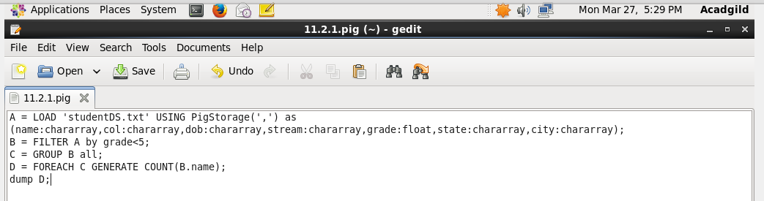

**Executing the pig script:**

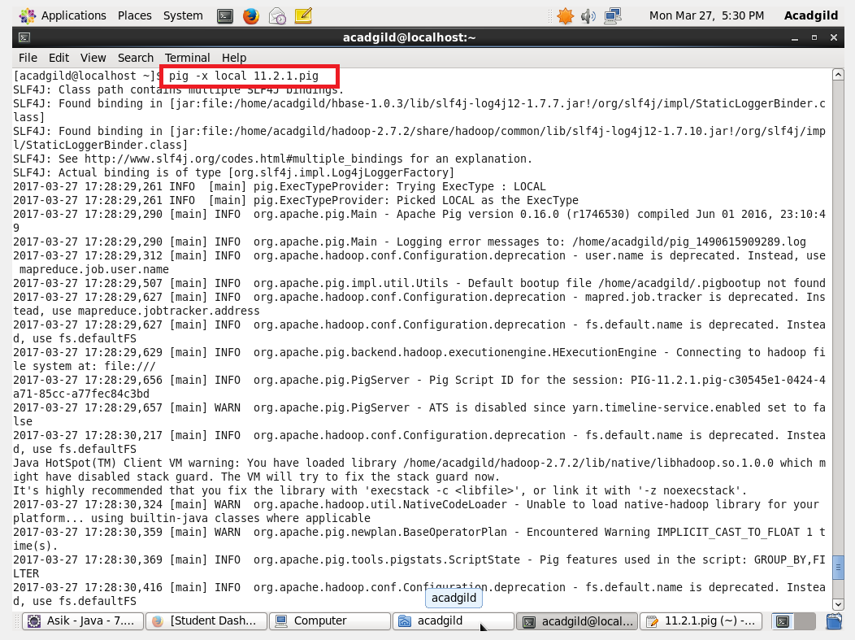

**Output:**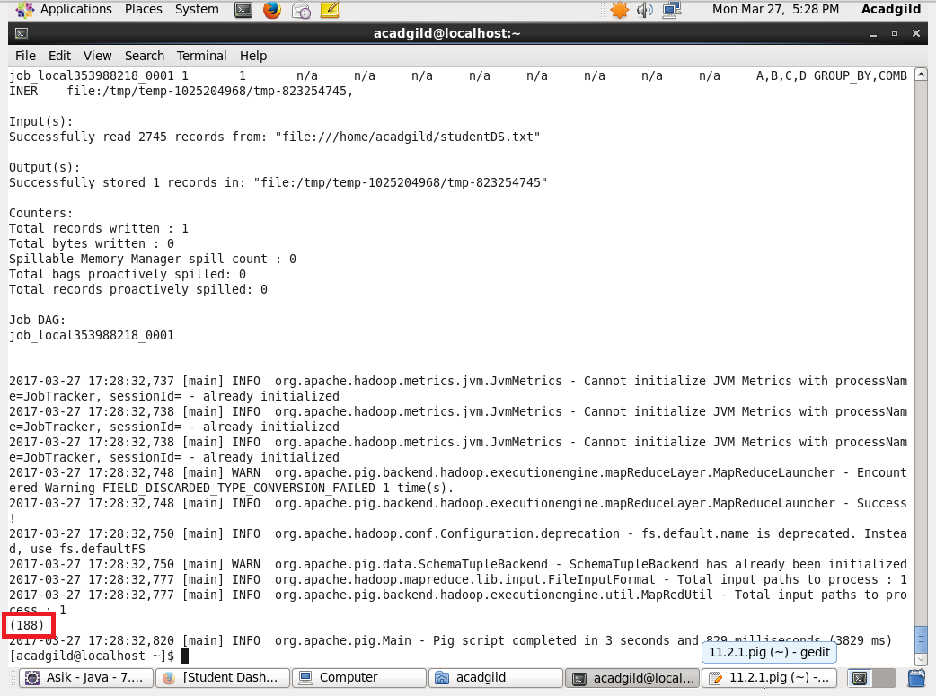

2. List the name of students who are from Alaska.

**Pig Script:**

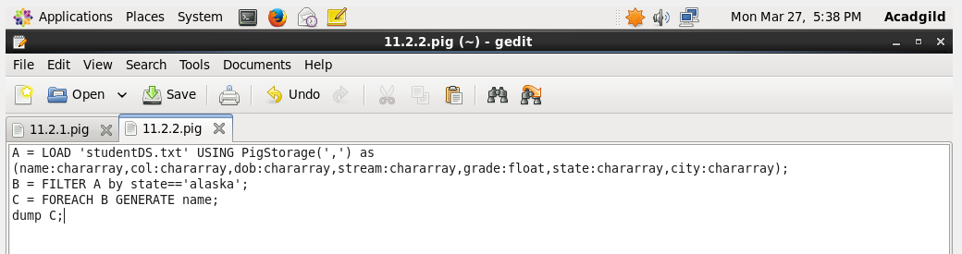

**Executing the Pig script:**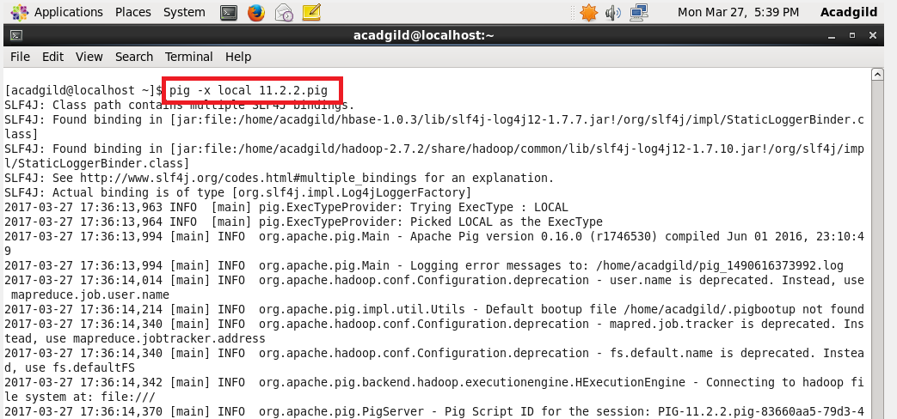

**Output:**

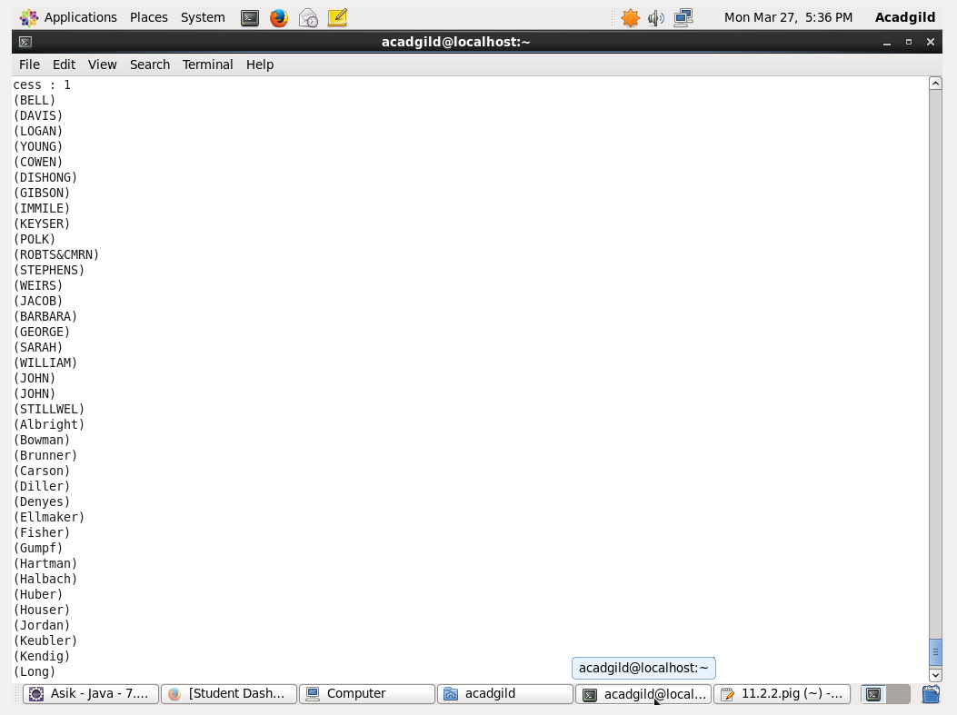

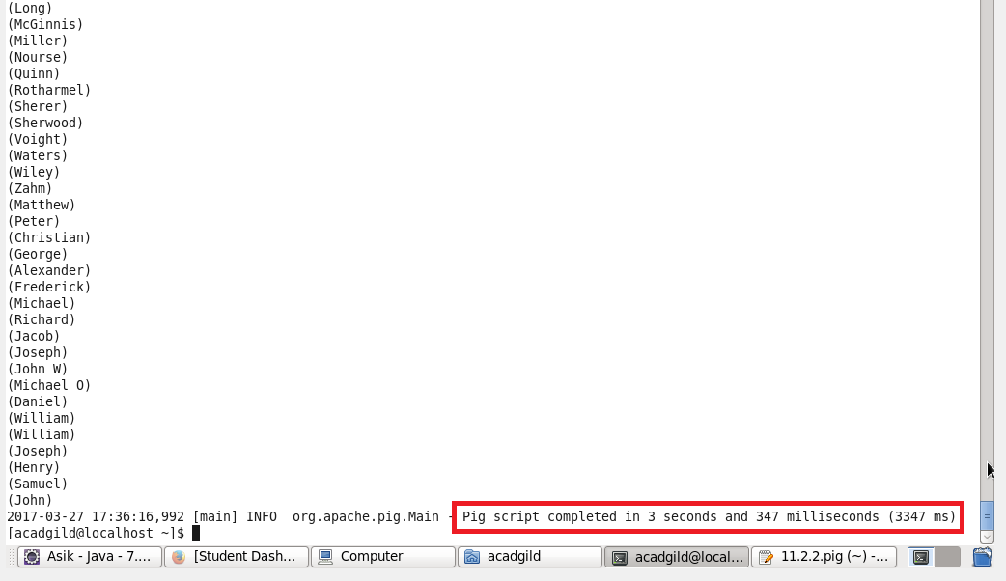

3. How many government colleges are there in Alabama?

**Pig Script:**

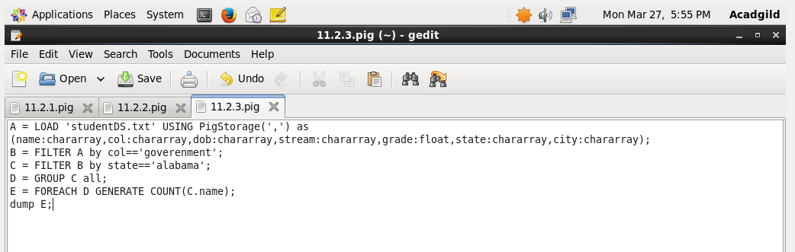

**Executing the pig script:**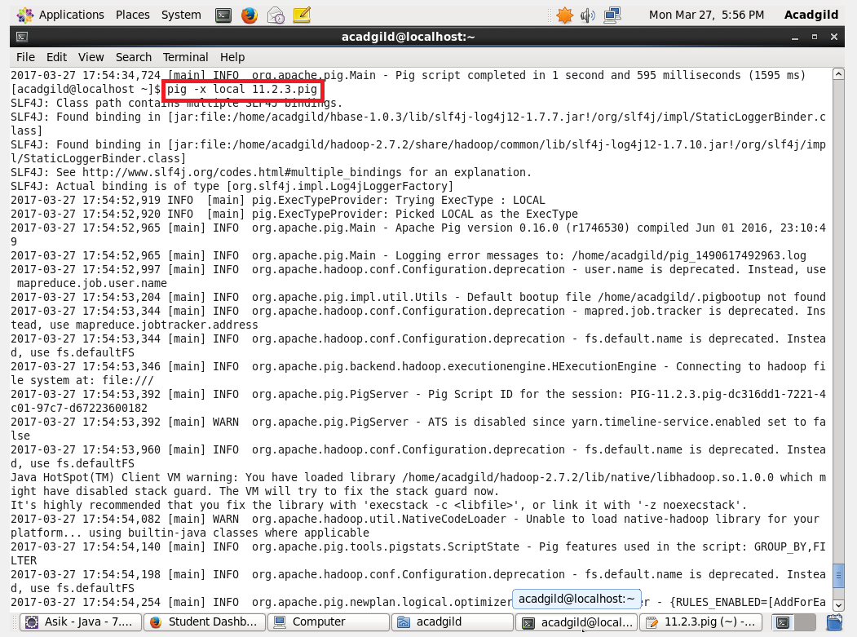

**Output:**

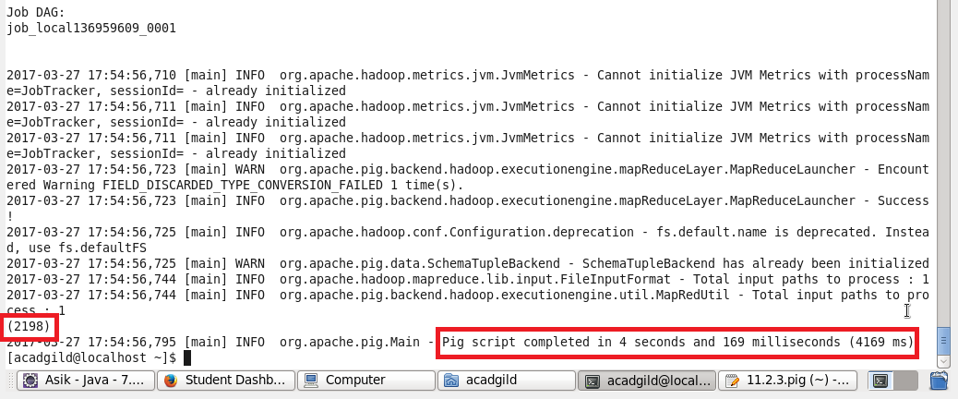

4. List the name of students who are from Oregon and persuing BE.

**Pig Script:**

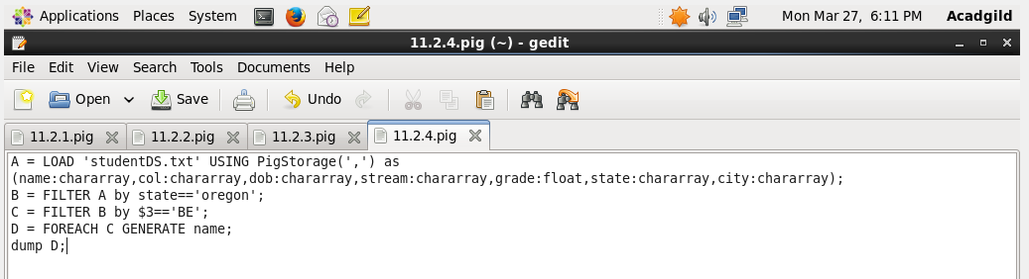

**Executing Pig Script:**

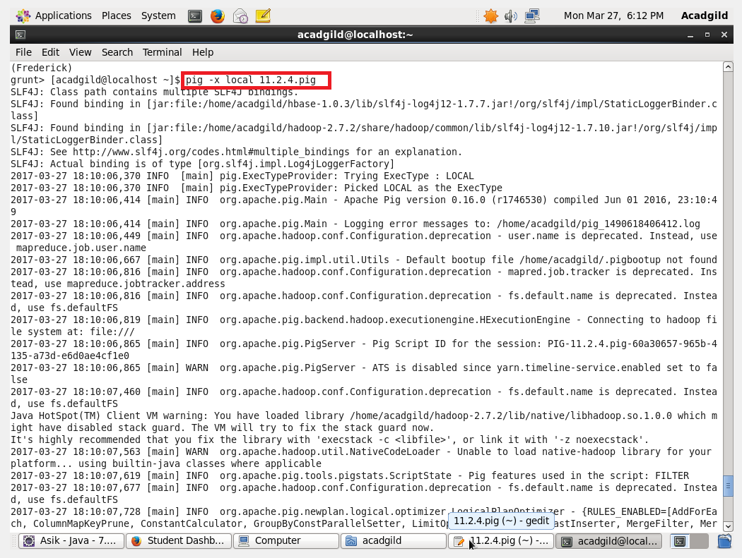

**Output:**